K L UNIVERSITY
FRESHMAN ENGINEERING DEPARTMENT

A Project Based Lab Report On

DTL-RO (Dynamic Transport Logistics & Route Optimization) SUBMITTED BY:
ID NUMBER NAME
2500031476 KRISHNA
2500031620 JASWANTH
2500031527 SHAHEED
2500031523 MADHUSUDAN

UNDER THE ESTEEMED GUIDANCE OF Dr. N SREERAM
ASSOCIATE PROFESSOR



KL UNIVERSITY
Green fields, Vaddeswaram – 522 502 Guntur Dt., AP, India.

DEPARTMENT OF BASIC ENGINEERING SCIENCES



CERTIFICATE

This is to certify that the project based laboratory report entitled “DTL-RO (Dynamic Transport Logistics & Route Optimization)” submitted by Krishna, T.Jaswanth , Shaheed, Madhusudhan bearing Regd. No. 2500031476, 2500031620, 2500031527, 2500031523 to the Department of COMPUTER SICENCE ENGINEERING , KL University in partial fulfillment of the requirements for the completion of a project based Laboratory in “Computational Thinking for Problem Solving (24SC1102)” course in I B Tech I Semester, is a Bonafede record of the work carried out by him/her under my supervision during the academic year 2024 – 2025.

PROJECT SUPERVISOR HEAD OF THE DEPARTMENT Dr. N SREERAM Dr. D. HARITHA

ACKNOWLEDGEMENTS

It is great pleasure for me to express my gratitude to our honorable President.

Sri. Koneru Satyanarayana, for giving the opportunity and platform with facilities in accomplishing the project-based laboratory report.
I express sincere gratitude to our Director Dr. A. Jagdeesh for his administration towards our academic growth.
I express sincere gratitude to our Coordinator and HOD-BES Dr. D. Haritha for her leadership and constant motivation provided in successful completion of our academic semester. I record it as my privilege to deeply thank you for providing us with the efficient faculty and facilities to make our ideas into reality.
I express my sincere thanks to our project supervisor Dr. Sree Ram Nimagada for her novel association of ideas, encouragement, appreciation, and intellectual zeal which motivated us to venture this project successfully.
Finally, we are pleased to acknowledge our indebtedness to all those who devoted themselves directly or indirectly to making this project a success.

Name: Krishna
T. Jaswanth
Shaheed
Madhusudhan

ID No: 2500031476
2500031620
2500031527
2500031523

ABSTRACT

The Dynamic Transport Logistics & Route Optimization Tool (DTL-RO) is a software system designed to improve the efficiency of transportation and last-mile delivery operations. It integrates order management, vehicle allocation, and route optimization into a single platform to minimize travel distance, time, and overall delivery cost.
The system models key components such as orders, vehicles, and delivery locations, and applies optimization techniques like greedy algorithms and advanced methods to generate efficient routes. It also considers practical constraints such as vehicle capacity and delivery scheduling.
DTL-RO supports real-time data handling by loading order details from CSV files and provides visualization of routes using map-based tools. Additionally, it includes an API layer for accessing route plans programmatically.
Overall, the project demonstrates how data structures, algorithms, and system design can be combined to build a scalable and efficient logistics solution for real-world applications.

INDEX

S.NO | TITLE | PAGE NO
1 | Introduction | 6
2 | Aim of the Project | 7
2.1 | Advantages & Disadvantages | 8
2.2 | Future Implementation | 8
3 | Software & Hardware Details | 9
4 | Data Flow Diagram | 10
5 | Algorithm for each module | 11
6 | Implementation | 12-15
7 | Integration and System Testing | 16
8 | Conclusion | 17

INTRODUCTION
In today’s fast-paced world, efficient transportation and delivery systems play a crucial role in ensuring timely service and customer satisfaction. With the rapid growth of e-commerce, food delivery, and local logistics services, managing multiple deliveries while minimizing time and cost has become a major challenge. Traditional methods of planning delivery routes manually are often inefficient, time-consuming, and unable to handle real-time changes effectively.
The Dynamic Transport Logistics & Route Optimization Tool (DTL-RO) is developed to address these challenges by providing an automated solution for route planning and logistics management. The system integrates order data, vehicle information, and location details to generate optimized delivery routes. It focuses on reducing travel distance, delivery time, and operational costs while ensuring efficient utilization of available resources.
This project uses fundamental concepts of Python programming, including data structures, algorithms, object-oriented programming, and file handling. It also incorporates technologies such as CSV data processing, map visualization, and API development to simulate a real-world logistics system.
Overall, the DTL-RO project demonstrates how computational techniques can be applied to solve practical transportation problems, making it a valuable learning tool as well as a foundation for building advanced logistics applications.

AIM

The aim of this project is to design and develop a Dynamic Transport Logistics & Route Optimization Tool that efficiently manages delivery operations by optimizing routes for vehicles. The system focuses on minimizing travel distance, time, and cost while ensuring effective utilization of resources such as vehicles and delivery schedules.
It also aims to integrate order management, vehicle assignment, and route planning into a single platform, providing real-time data handling, visualization of delivery routes, and an API-based interface for scalability. Ultimately, the project demonstrates how algorithms and data-driven approaches can be used to solve real-world logistics and transportation problems efficiently.

ADVANTAGES
- Reduces Travel Time & Distance
Optimizes routes for faster and more efficient deliveries.
- Cost Efficient
Lowers fuel and operational costs by minimizing unnecessary travel.
- Better Resource Utilization
Effectively uses vehicles based on capacity and availability.
- Handles Multiple Deliveries
Manages many orders and vehicles simultaneously with ease.
- Real-Time Adaptability
Can update routes dynamically when new orders or changes occur.

DISADVANTAGES
- Complex Implementation
Involves algorithms, APIs, and multiple modules, which can be difficult to build and understand.
- Dependent on Data Accuracy
Incorrect input data (locations, orders) can produce wrong routes.
- Limited Real-Time Accuracy
Without live traffic data, routes may not always be optimal in real-world conditions.
- Performance Limitations
Basic algorithms may not give the best solution for large or complex datasets.
- Scalability Issues
Simple version may struggle when handling many orders and vehicles.

FUTURE IMPLEMENTATION
- Add real-time traffic data for better route accuracy
- Use advanced algorithms (OR-Tools) for optimal routing
- Develop a mobile app for drivers
- Enable live vehicle tracking
- Integrate with a database for large-scale data handling

SYSTEM REQUIREMENTS

SOFTWARE REQUIREMENTS:
- Python 3.x
- VS Code / PyCharm
- Libraries: pandas, folium, fastapi
- Web Browser (for map & API output)

HARDWARE REQUIREMENTS:
- Processor: Intel i3 or above
- RAM: 4 GB (minimum)
- Storage: 500 MB free space
- System: Laptop/Desktop
- Internet: Required (for API & maps)

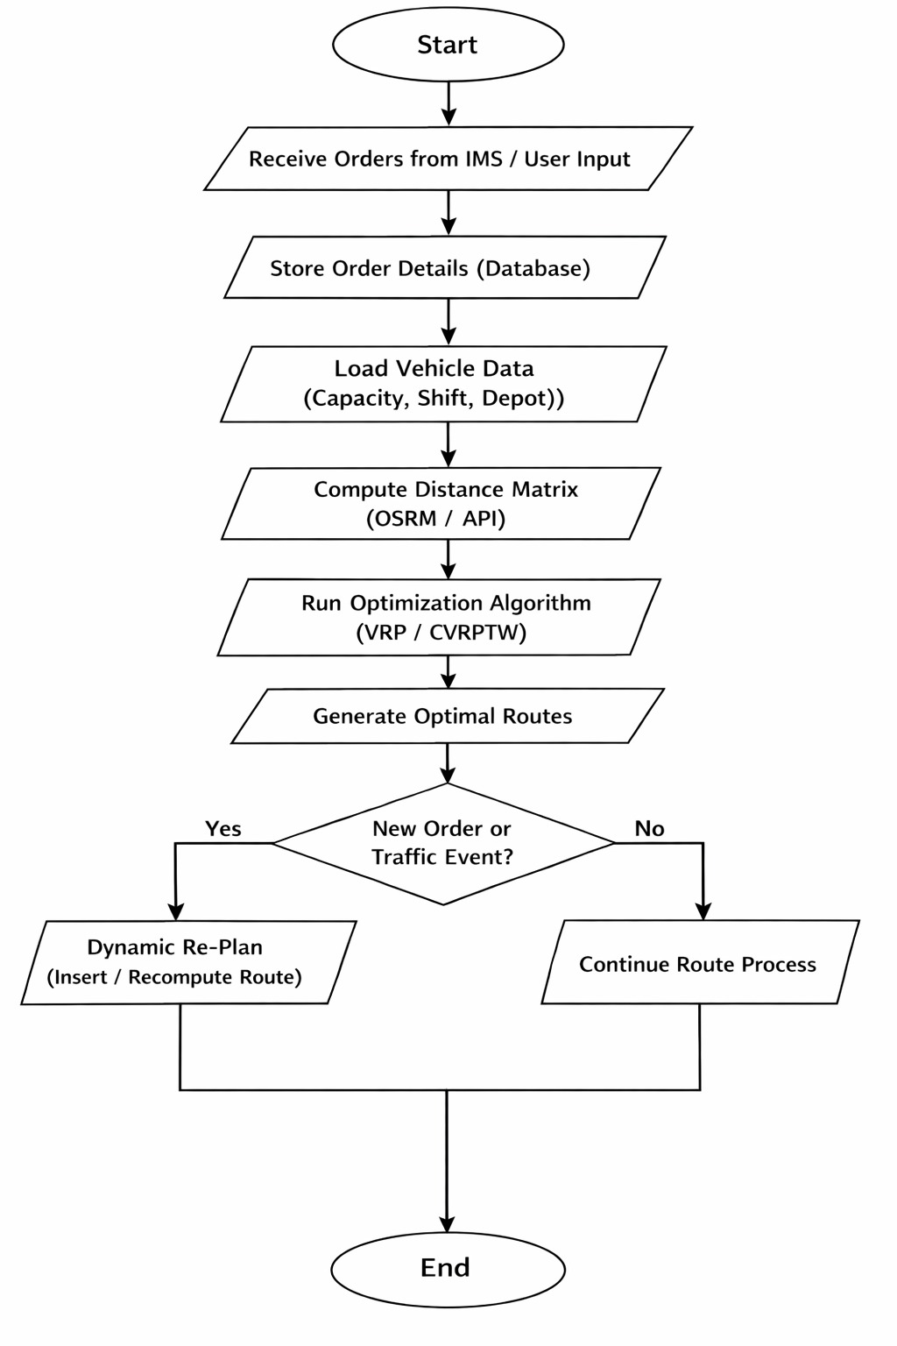
9

ALGORITHM

Step 1: Start
Step 2: Input Data
- Read orders (locations, weights)
- Read vehicle details (capacity)
Step 3: Initialize
- Select starting point (Depot / first order)
- Mark all orders as unvisited
Step 4: Select Next Location
- From current location, find the nearest unvisited order
Step 5: Update Route
- Add selected order to route
- Mark it as visited
Step 6: Repeat
- Repeat Steps 4–5 until all orders are visited
Step 7: Assign to Vehicles
- Distribute orders among vehicles based on capacity
Step 8: Generate Output
- Display optimized route
- Show map visualization
Step 9: End

9

IMPLEMENTATION

import pandas as pd
import json
import matplotlib.pyplot as plt
def load_shipments(file_path):
df = pd.read_csv(file_path)
print("\nShipment Data:\n", df)
return df
def load_distances(file_path):
with open(file_path, 'r') as f:
distances = json.load(f)
return distances
def optimize_route(start, distances):
visited = set()
route = [start]
current = start
total_distance = 0
while len(visited) < len(distances) - 1:
visited.add(current)
nearest = None
min_dist = float('inf')
for city, dist in distances[current].items():
if city not in visited and dist < min_dist:
nearest = city
min_dist = dist
if nearest:
route.append(nearest)
total_distance += min_dist
current = nearest
return route, total_distance
def save_results(route, distance):
with open("output.txt", "w") as f:
f.write(f"Optimized Route: {' -> '.join(route)}\n")
f.write(f"Total Distance: {distance}\n")
def plot_route(route, distances):
dists = []
for i in range(len(route) - 1):
dists.append(distances[route[i]][route[i+1]])
plt.plot(range(len(dists)), dists, marker='o')
plt.title("Route Distance Between Stops")
plt.xlabel("Step")
plt.ylabel("Distance")
plt.grid()
plt.show()
def main():
shipments = load_shipments("shipments.csv")
distances = load_distances("distances.json")
start_city = shipments['source'][0]
route, total_distance = optimize_route(start_city, distances)
print("\nOptimized Route:", route)
print("Total Distance:", total_distance)
save_results(route, total_distance)
plot_route(route, distances)
if __name__ == "__main__":
main()

INTEGRATION AND SYSTEM TESTING
OUTPUTS

Screen Shots:

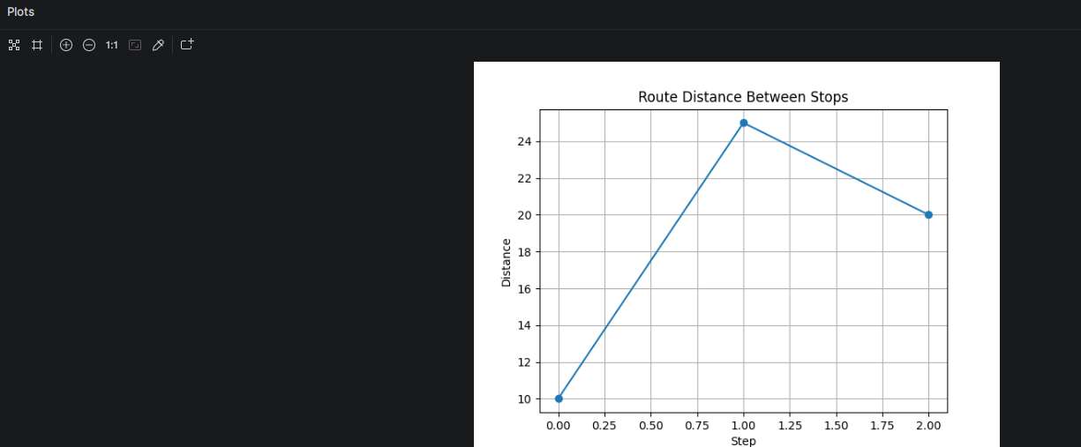

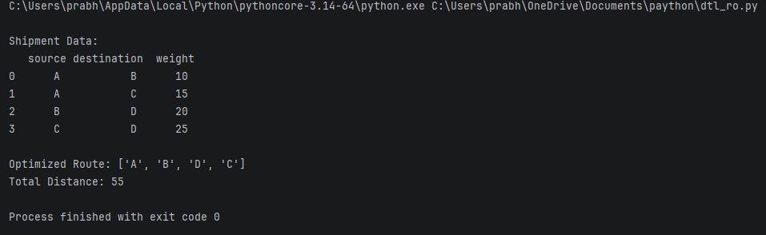

16

CONCLUSION

The Dynamic Transport Logistics & Route Optimization Tool (DTL-RO) successfully demonstrates how delivery operations can be managed and optimized using programming techniques. The system takes order details as input, processes them using a greedy optimization algorithm, and assigns routes to vehicles efficiently while considering capacity constraints.
The project integrates multiple concepts such as object-oriented programming, file handling, data analysis, and map visualization to provide a complete logistics solution. It helps in reducing travel distance, improving resource utilization, and simplifying route planning.
Overall, the project achieves its objective of building a functional and efficient route optimization system. It also serves as a strong foundation for developing advanced real-world logistics applications with additional features like real-time tracking and intelligent routing.

